Access permissions are split into the following categories:
- Owner - Full access to the calendar, including the ability to add, change and remove access permissions of others.
- Publishing Editor - The ability to add, change and delete appointments and create subfolders where applicable.
- Editor - The ability to add, change and delete appointments.
- Publishing Author - The ability to create new appointments, change and delete items they have created and create subfolders where applicable.
- Author - The ability to create new appointments, change and delete items they have created.
- Contributor - The ability to create appointments. Cannot change items they have created or view other items.
- Reviewer - "Viewer" access to read all appointments.
- Custom - A specially selected set of permissions, which can be shown by examining each user's access permission.
- None - No access to the calendar (typically the default).
The most common access permissions you may want to grant are Editor and Reviewer.

Managing Calendar Access Permissions from Outlook
If you haven't already connected Outlook to your shared calendar, you can do so by following these instructions. Once connected, you should see the calendar in your normal calendar list:
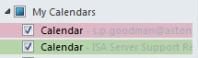
To manage access permissions, right click on the calendar and choose Properties:
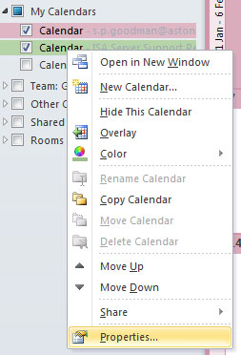
The Properties window should open. Click on the Permissions tab. You should see the list of people who already have access to the calendar.
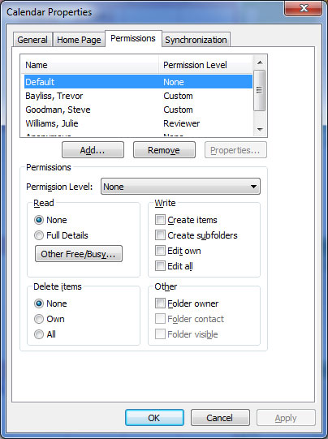
To see the access permissions of an existing user, left click on their name in the list. The general permissions level is shown beside Permissions Level. The exact access permissions this provides is shown below. You can change the permissions either by selecting the exact access permission required, or using the drop down menu to select one of the provided access permissions levels, as shown below:
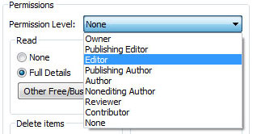
You can also add access permissions to someone who isn't shown in the list by left-clicking on the Add...button, selecting the person's mailbox from the Global Address List and finally choosing the permissions level they should be provided with:
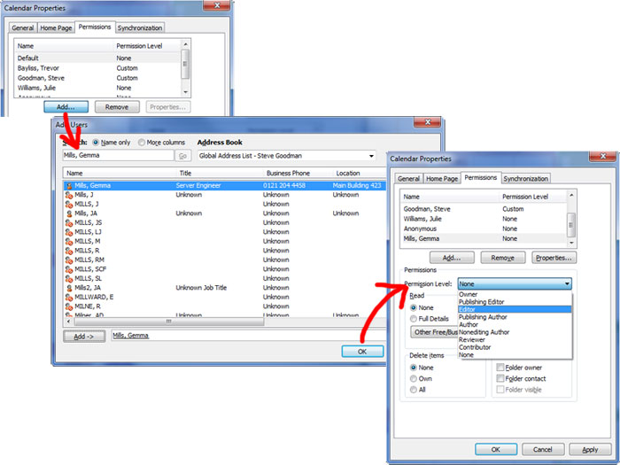
After completing the access permissions modifications, notify the people you have added / amended access permissions for of the changes and direct them to this section of the ISA site for further instructions on accessing the calendar.

